Employee Management System Project
This project explains the Employee Management System. It shows how employees are created and how attendance is recorded using activity diagrams. The diagrams help explain how the system works step by step.

1. Activity Diagram – Create Employee
This diagram shows how a manager creates a new employee in the system.
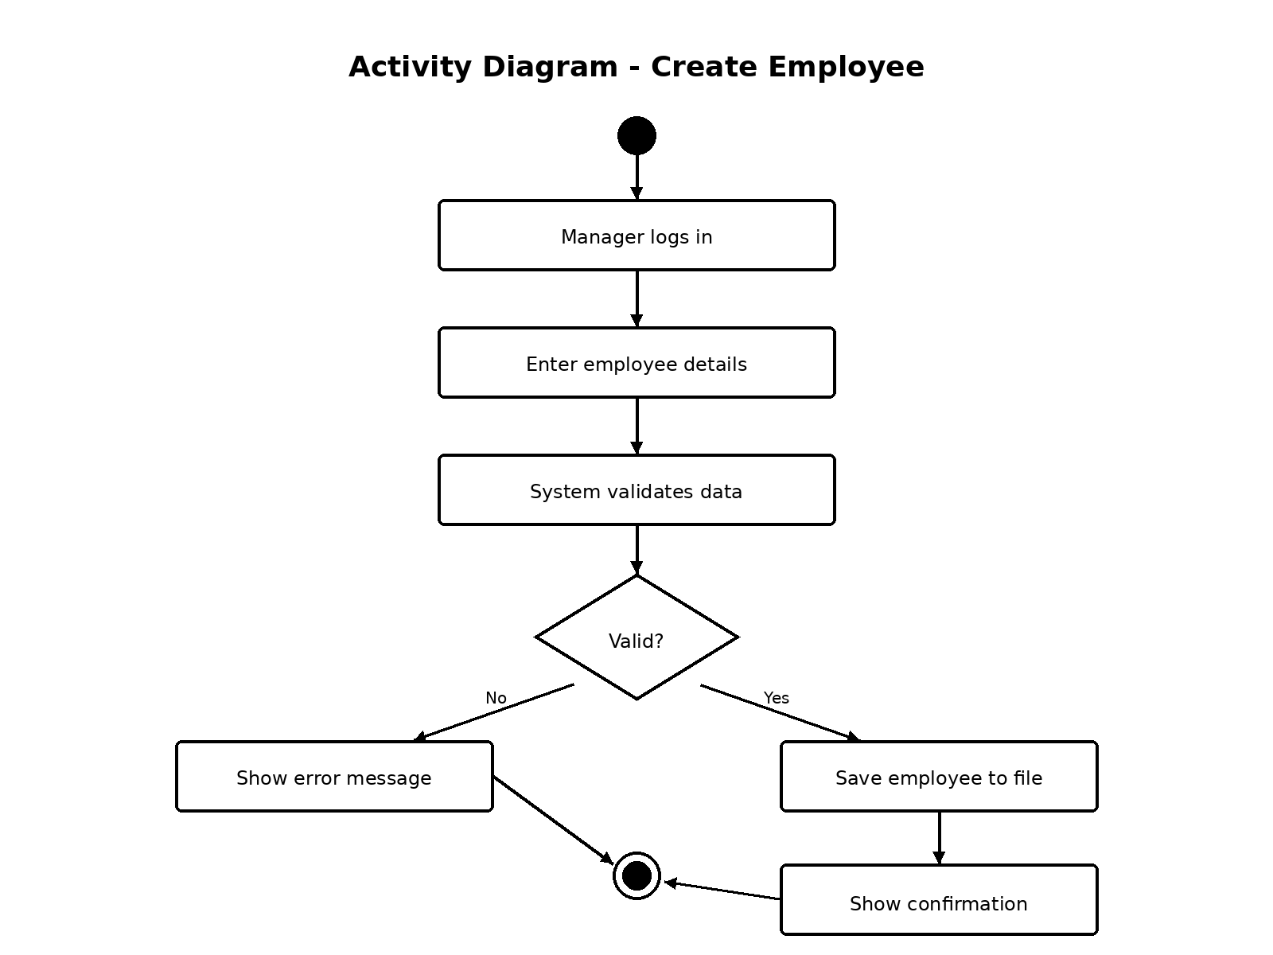
Explanation:
- The manager logs into the system.
- The system checks if the login is correct.
- The manager enters the employee’s information.
- The system checks if the information is valid.
- If the information is correct, the system saves the employee and shows a confirmation message.
- If the information is not correct, the system shows an error message.

2. Activity Diagram – Record Attendance
This diagram shows how an employee records their attendance.
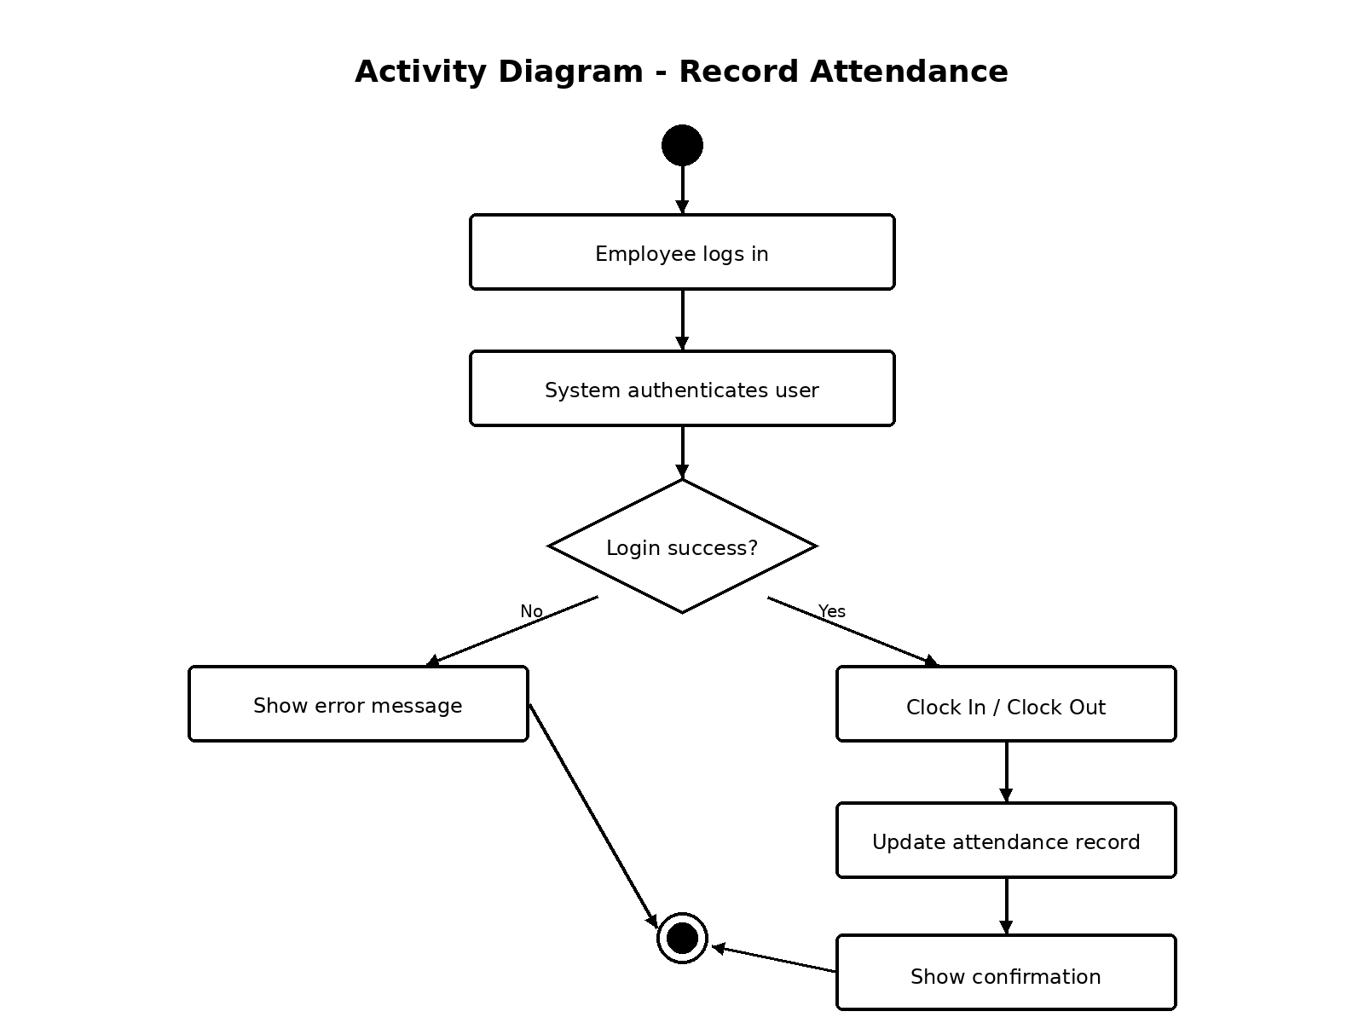
Explanation:
- The employee logs into the system.
- The system checks if the login is successful.
- If login works, the employee can clock in or clock out.
- The system calculates the hours worked.
- The system updates the attendance record in the database.
- The system shows a confirmation message.
- If login fails, the system shows an error message.

Conclusion
The Employee Management System helps managers create employees and helps employees record attendance. The activity diagrams clearly show how the system works from start to finish. Each process begins with a login and ends with either a confirmation message or an error message.

